1. **Proof of status in Canada**: such as a Canadian passport, birth certificate, PR card, COPR, Indian Status card, etc.

**REQUIRED FROM THE SPONSOR**

1. **Notice of Assessment**:from the most recent year found on your CRA account.
2. **Proof of Income Statement**: from the most recent year found on your CRA account.
3. **Proof of current employment/financial support,** 
   1. **Bank statement of the past 3 months or a bank balance certificate** demonstrating your ability to support the principal applicant and dependents
   2. **at least one of the following**
      1. **a** **letter from your employer** confirming that you are currently employed, including the hours worked and your salary or wage.
      2. **documents proving that you own a business** and are able to support the principal applicant and any dependents.
4. **Address history over the past 5 years (or since 18th birthday if it was less than 10 years ago)**: for each address, include the start date, end date, street and number, city, province/state, country, and postal code.
5. **Travel history over the past 10 years (or since 18th birthday if it was less than 10 years ago)**: for each trip, include the start date, end date, city and country, purpose of travel, and the number of days spent on the trip.
6. **Employment history over the past 5 years (or since 18th birthday if it was less than 10 years ago)**: for each employer, include the start and end dates, business/employer name, your occupation/position there, and your monthly gross income during your employment. **YOU MUST INCLUDE PERIODS OF UNEMPLOYMENT AND HOW YOU SUPPORTED YOURSELF**.
7. **Documents from any previous marriage(s) or common-law relationship(s)**:such as marriage certificates, annulments, declarations of common-law, divorce certificates, etc.
8. **Proof of status in Canada**:if applying from within Canada provide a valid Canadian Visa, Visitor Record, Study Permit, Work Permit, etc.

**REQUIRED FROM THE PRINCIPAL APPLICANT & ANY ACCOMPANYING DEPENDENTS**

1. **Passports or travel documents**: (valid and expired) include any page containing seals, stamps, or marking of any kind.
2. **Travel history over the past 10 years (or since 18th birthday if it was less than 10 years ago)**: for each trip, include the start date, end date, city and country, purpose of travel, and the number of days spent on the trip.
3. **Employment history over the past 5 years (or since 18th birthday if it was less than 10 years ago)**: for each employer, include the start and end dates, business/employer name, your occupation/position there, and your monthly gross income during your employment. **YOU MUST INCLUDE PERIODS OF UNEMPLOYMENT AND HOW YOU SUPPORTED YOURSELF**.
4. **Personal activity history over the past 10 years (or since 18th birthday if it was less than 10 years ago)**:details of all your employment, education, travels, etc. If you were not working, provide information on what you were doing (unemployed, studying, travelling, retired, in detention, etc.). if you were outside your country or territory of nationality, indicate your status in the country or territory you were in. Include the start and end dates, your activity at the time, city & country, status at the country where you were at, and the employer/institution you were a part of if applicable.
5. **Education history since secondary school and onwards**:for all secondary and post-secondary education, whether complete, incomplete, or ongoing, include the start and end dates, name of the institution, city & country, the type of certificate/level of education, and the major/field of study.
6. **Family information**:for each sibling (including step- and half-) and parent (including step-), include their email address, residential address, full legal name in English and native language, date and city & country of birth, date and city & country of death, if deceased, marital status, and their relationship to you (brother, mother, etc.)
7. **Documents from any previous marriage(s) or common-law relationship(s)**:such as marriage certificates, annulments, declarations of common-law, divorce certificates, etc.
8. **Police Clearance Certificate(s)**: a valid police clearance certificate for any country you have resided for at least 6 months since the age of 18 (except Canada).
9. **Legal name changes**: Provide evidence of all legal name changes for both the sponsor and the sponsored spouse, if applicable.
10. **Birth certificate**: Provide a certified copy of the birth certificate for the sponsored spouse.
11. **Financial and Employment documents**: Provide a letter of employment if you are working in your home country or Canada (must have valid authorization to work in Canada), along with bank statements.
12. **Court, police, and prison records**: Provide court, police, and prison records, if applicable.
13. **Immigration violation records**: Provide immigration violation records, if applicable.
14. **Passport photographs**: Provide a photograph for the principal applicant, following the specifications:

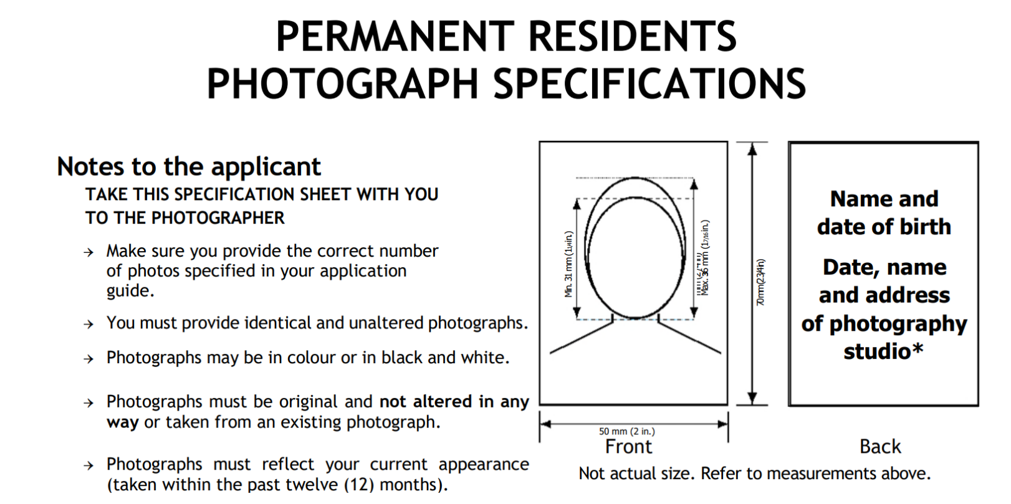

1. **Proof of financial support**: provide evidence of financial support between the principal applicant and the sponsor, such as bank transfers, receipts, etc.

**EVIDENCE FOR THE PROOF OF RELATIONSHIP**

1. **Children**: If applicable, provide documentation to prove that the sponsor and the sponsored spouse have child(ren) together.
2. **Marriage Certificate or License, and/or religious marriage documents.**
3. **Photographs of relationship, marriage events, honeymoon**: provide photos of the wedding, customary celebrations, engagement, outings, and other events to support the relationship. Include the date and description of the photo, and names and relationship of each person present.
4. **Proof of contact**: provide proof of contact, such as letters, printed text messages, emails, or social media conversations, and proof of sponsor's visits, such as airline ticket, used boarding passes, and photocopies of passport pages showing entry-exit stamps. Provide certified translations for all non-English or non-French documents.
5. **Joint ownership of residential property or rental agreements** **(if the applicant is in Canada)**: Provide at least one document to prove joint ownership or joint tenancy of a residential property.
6. **Joint utilities accounts** **(if the applicant is in Canada)**: Provide at least one document to prove joint utilities accounts, such as electricity, gas, or telephone bills.
7. **Documents showing the same address** **(if the applicant is in Canada)**: provide documents for both the sponsor and the applicant showing the same address, such as government-issued identification documents, driver's licenses, or insurance policies.
8. **Affidavits and statements from friends and family**: provide proof that the relationship is recognized by friends and/or family, such as letters or affidavits.
9. **Social media information showing a public relationship**: such as Facebook relationship statuses stating marriage between the applicant and the sponsor.